The JOIN operation

1. SELECT matchid, player FROM goal WHERE teamid = 'GER'

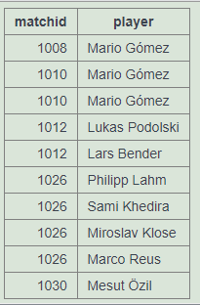

1. SELECT id,stadium,team1,team2 from game where id in (select matchid from goal where matchid = 1012)

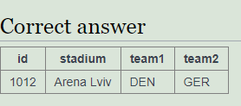

1. SELECT player, teamid, stadium, mdate FROM game JOIN goal ON (game.id=goal.matchid) where goal.teamid = 'GER'

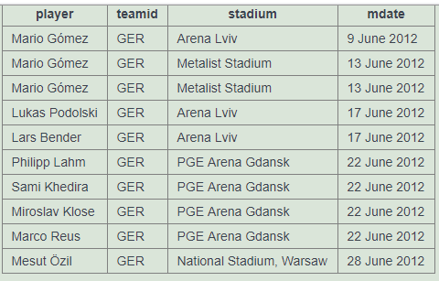

1. SELECT team1, team2, player FROM game JOIN goal ON (game.id=goal.matchid) where player like 'Mario%'

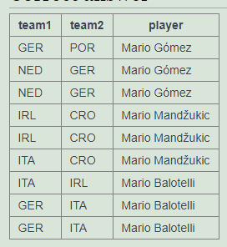

1. SELECT player, teamid, coach, gtime FROM goal join eteam ON (eteam.id=goal.teamid) WHERE gtime<=10

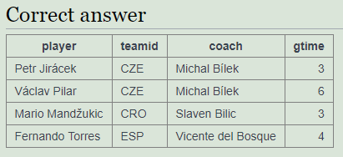

1. select mdate, teamname from game JOIN eteam ON (game.team1=eteam.id) where eteam.coach = 'Fernando Santos'  
   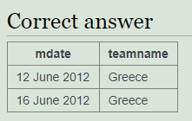
2. select goal.player from game JOIN goal ON (game.id=goal.matchid) where game.stadium = 'National Stadium, Warsaw'

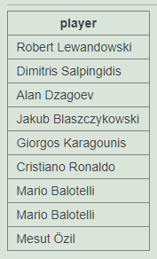

1. SELECT distinct player FROM game JOIN goal ON matchid = id WHERE (team1='GER' OR team2='GER') and teamid != 'GER'

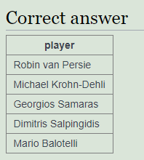

1. SELECT teamname, count(teamid) FROM eteam JOIN goal ON id=teamid group BY teamname

|  |  |
| --- | --- |
| **teamname** | **count(teamid)** |
| Croatia | 4 |
| Czech Republic | 4 |
| Denmark | 4 |
| England | 5 |
| France | 3 |
| Germany | 10 |
| Greece | 5 |
| Italy | 6 |
| Netherlands | 2 |
| Poland | 2 |
| Portugal | 6 |
| Republic of Ireland | 1 |
| Russia | 5 |
| Spain | 12 |
| Sweden | 5 |
| Ukraine | 2 |

1. select stadium, count(*) from game JOIN goal ON (game.id=goal.matchid) group by stadium

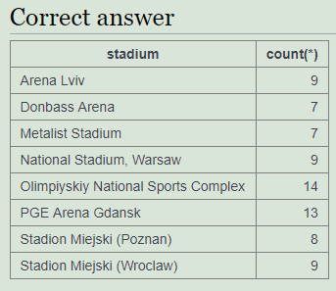

1. SELECT matchid, mdate, count(*) FROM game JOIN goal ON matchid = id WHERE (team1 = ‘POL' OR team2 = 'POL') group by matchid, mdate

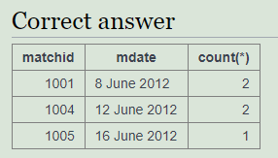

1. select matchid, mdate, count(*) from game JOIN goal ON matchid = id where teamid = 'GER' group by matchid, mdate

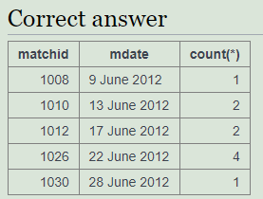

1. SELECT distinct mdate, team1, SUM(CASE WHEN teamid=team1 THEN 1 ELSE 0 END) score1, team2, SUM(CASE WHEN teamid=team2 THEN 1 ELSE 0 END) score2 FROM game LEFT JOIN goal ON game.id = goal.matchid GROUP BY id, mdate, team1, team2 ORDER BY mdate, matchid, team1, team2

|  |  |  |  |  |
| --- | --- | --- | --- | --- |
| **mdate** | **team1** | **score1** | **team2** | **score2** |
| 1 July 2012 | ESP | 4 | ITA | 0 |
| 10 June 2012 | ESP | 1 | ITA | 1 |
| 10 June 2012 | IRL | 1 | CRO | 3 |
| 11 June 2012 | FRA | 1 | ENG | 1 |
| 11 June 2012 | UKR | 2 | SWE | 1 |
| 12 June 2012 | GRE | 1 | CZE | 2 |
| 12 June 2012 | POL | 1 | RUS | 1 |
| 13 June 2012 | DEN | 2 | POR | 3 |
| 13 June 2012 | NED | 1 | GER | 2 |
| 14 June 2012 | ITA | 1 | CRO | 1 |
| 14 June 2012 | ESP | 4 | IRL | 0 |
| 15 June 2012 | UKR | 0 | FRA | 2 |
| 15 June 2012 | SWE | 2 | ENG | 3 |
| 16 June 2012 | CZE | 1 | POL | 0 |
| 16 June 2012 | GRE | 1 | RUS | 0 |
| 17 June 2012 | POR | 2 | NED | 1 |
| 17 June 2012 | DEN | 1 | GER | 2 |
| 18 June 2012 | CRO | 0 | ESP | 1 |
| 18 June 2012 | ITA | 2 | IRL | 0 |
| 19 June 2012 | ENG | 1 | UKR | 0 |
| 19 June 2012 | SWE | 2 | FRA | 0 |
| 21 June 2012 | CZE | 0 | POR | 1 |
| 22 June 2012 | GER | 4 | GRE | 2 |
| 23 June 2012 | ESP | 2 | FRA | 0 |
| 24 June 2012 | ENG | 0 | ITA | 0 |
| 27 June 2012 | POR | 0 | ESP | 0 |
| 28 June 2012 | GER | 1 | ITA | 2 |
| 8 June 2012 | POL | 1 | GRE | 1 |
| 8 June 2012 | RUS | 4 | CZE | 1 |
| 9 June 2012 | NED | 0 | DEN | 1 |
| 9 June 2012 | GER | 1 | POR | 0 |